Home Page

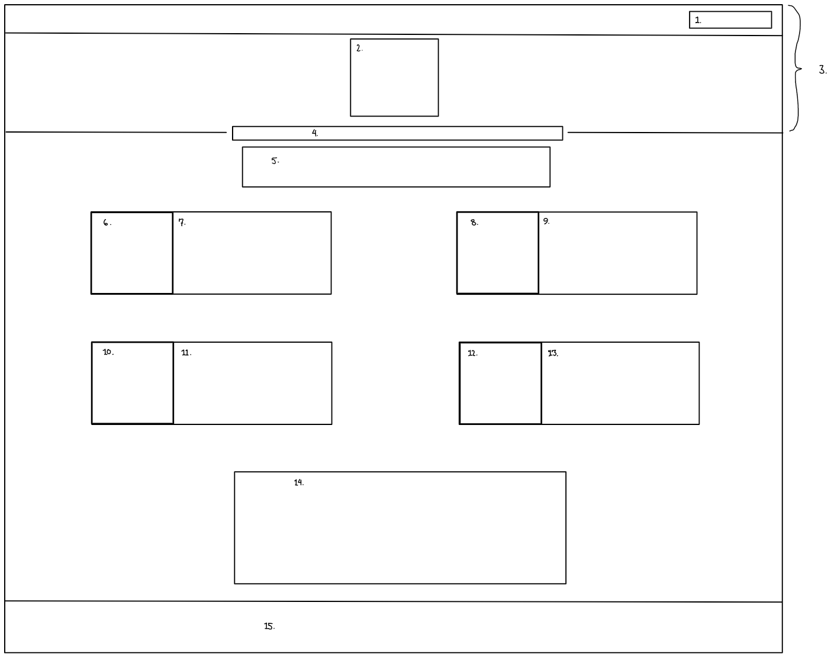

1. Log-in boxes
2. Podcast logo
3. Header
4. Navigation bar
5. Mission statement
6. Icon, listen to episodes
7. Listen to episodes
8. Icon, blog
9. Blog
10. Icon, about us
11. About us
12. Icon, contact us
13. Contact us
14. Image(s)
15. Footer

Listen Page

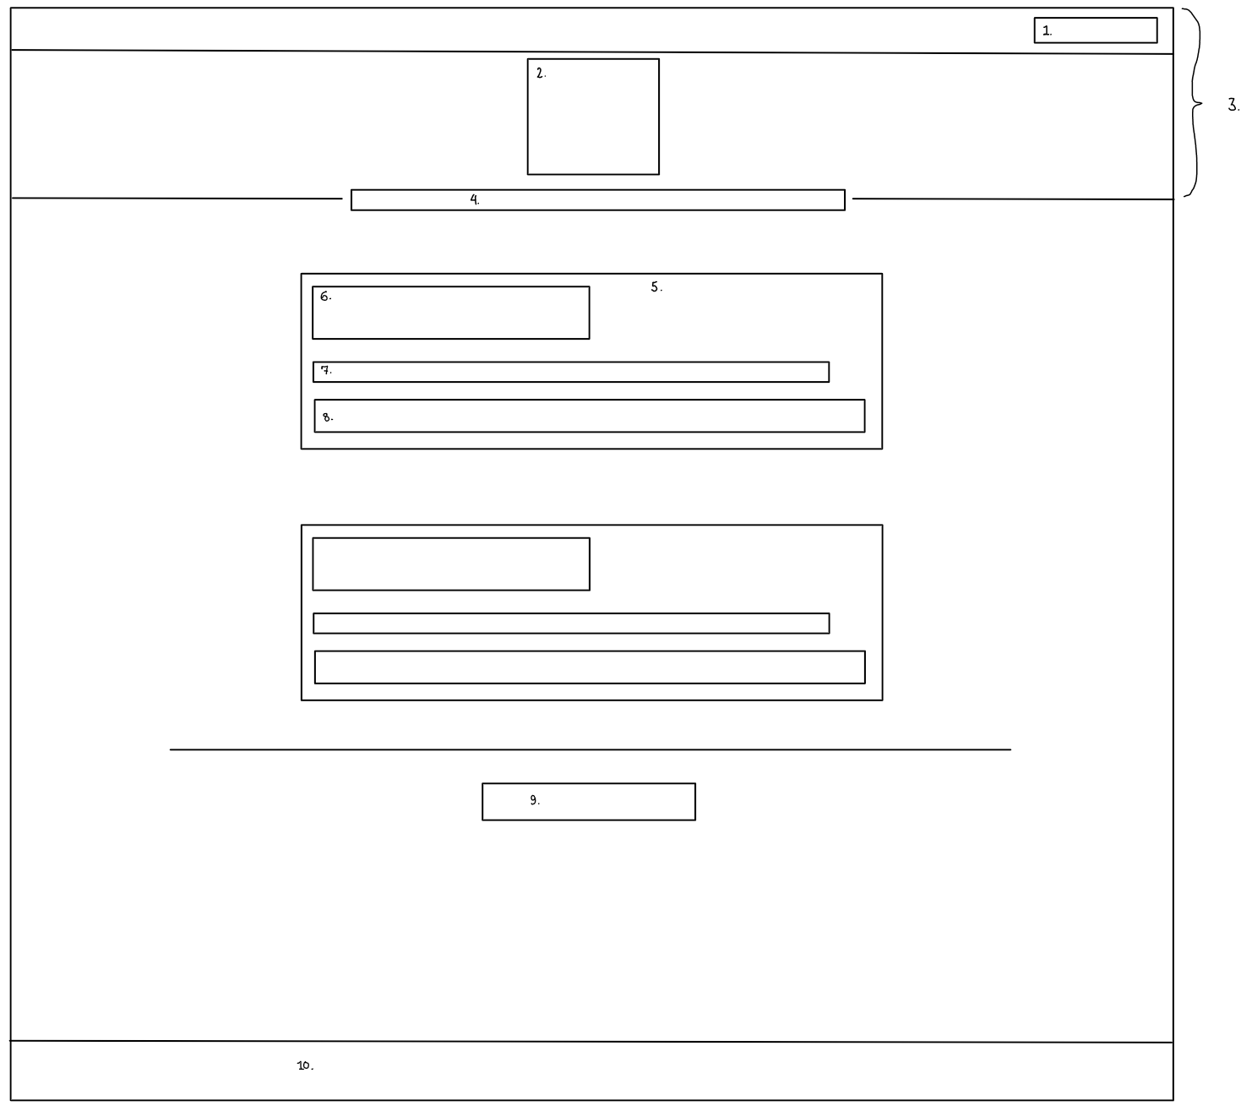

1. Log-in boxes
2. Podcast logo
3. Header
4. Navigation bar
5. Episode
6. Episode name
7. Episode description
8. MP3 status bar
9. Notice: Log in (or sign up) to access more episodes
10. Footer

Blog Page

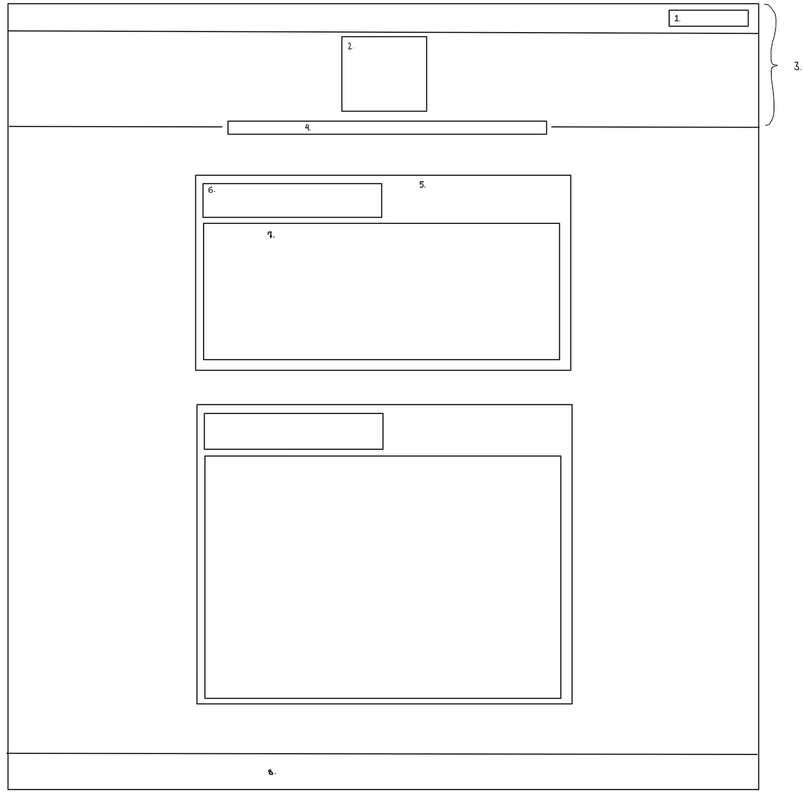

1. Log-in boxes
2. Podcast logo
3. Header
4. Navigation bar
5. Discussion Box
6. Subject, date
7. Text

About Page

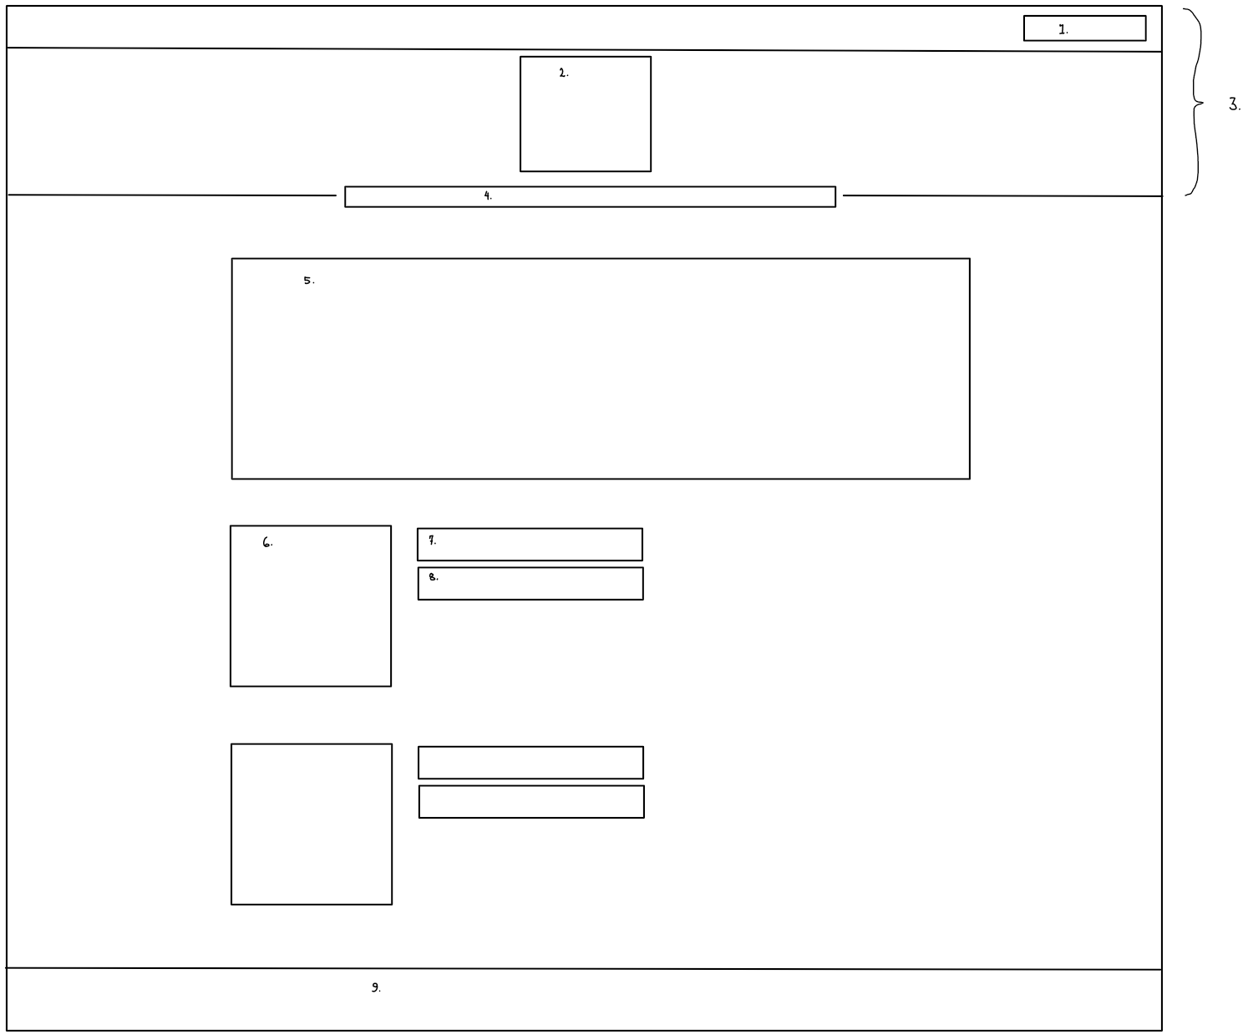

1. Log-in boxes
2. Podcast logo
3. Header
4. Navigation bar
5. About Podcast
6. Host Picture
7. Host name
8. Host title

Contact Page

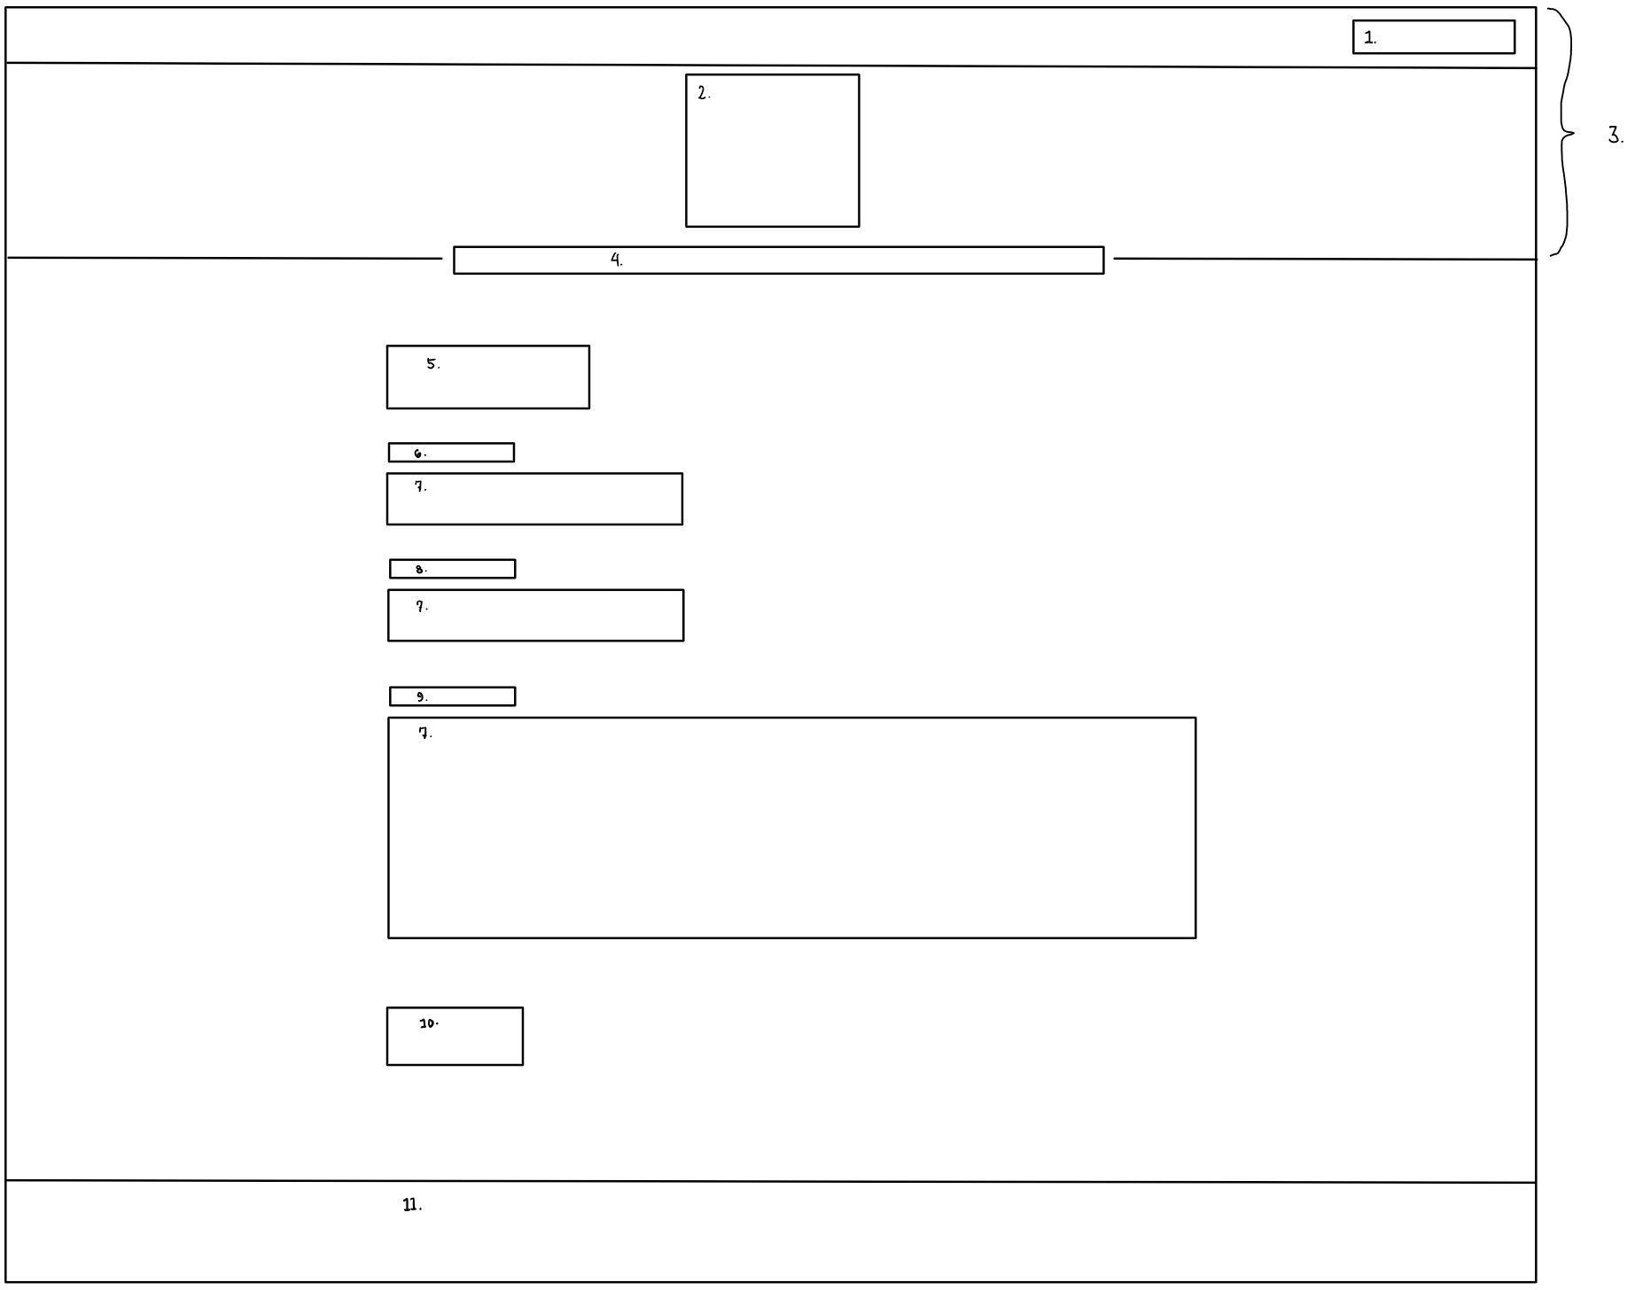

1. Log-in boxes
2. Podcast logo
3. Header
4. Navigation bar
5. "Contact"
6. Name title
7. Input field
8. Email title
9. Comment title
10. Submit button

Login Page

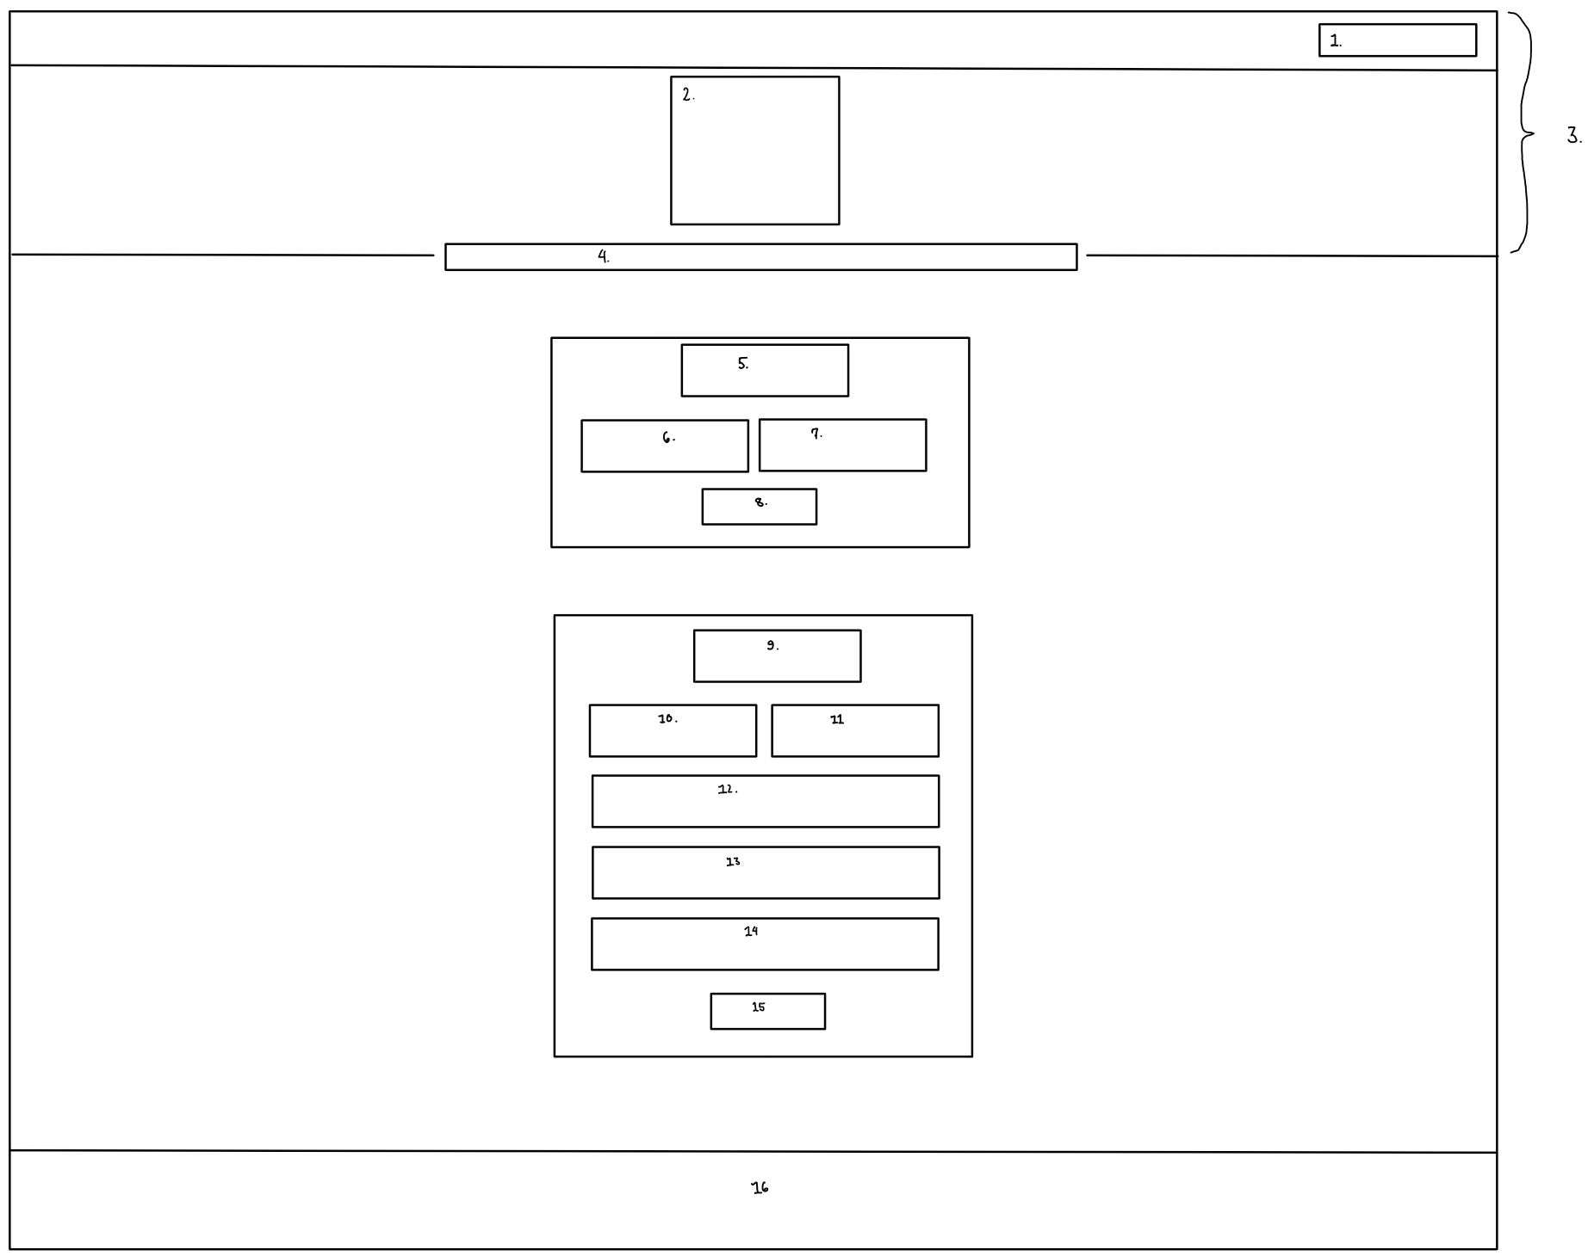

1. Log-in boxes
2. Podcast logo
3. Header
4. Navigation bar
5. Log-in header
6. Username
7. Password
8. Log-in button
9. Sign-up header
10. First name
11. Last name
12. User name
13. Password
14. Email
15. Sign-up button
16. Footer